Prior knowledge | This course requires no previous knowledge of Unity.
Programs & setup | Students can follow along with Unity. Students will need to install both Unity and Visual Studio Community (which should come packaged with the Unity installation).  The installation of Unity is NOT covered in this course. However, you can find basic setup information for Unity below.

Installing Unity and Registering a Student Account

1. Installing Unity
Unity is a cross-platform game engine developed by Unity Technologies. It is widely used for creating a variety of games, simulations, and other interactive 3D content. Here is how to install Unity:

1.1 Visit Unity's Download Page
Go to Unity's official download page at https://unity3d.com/get-unity/download

1.2 Download Unity Hub
Unity Hub is a management tool for Unity. Click on the button that says "Download Unity Hub".

1.3 Install Unity Hub
Once the download is complete, find the downloaded file and double-click on it to start the installation process. Follow the prompts to install Unity Hub on your machine.

1.4 Install Unity Editor
After installing Unity Hub, open it and navigate to the "Installs" section. Click the "Add" button and choose the version of Unity you wish to install. Then, click "Next" to start the Unity Editor installation process.
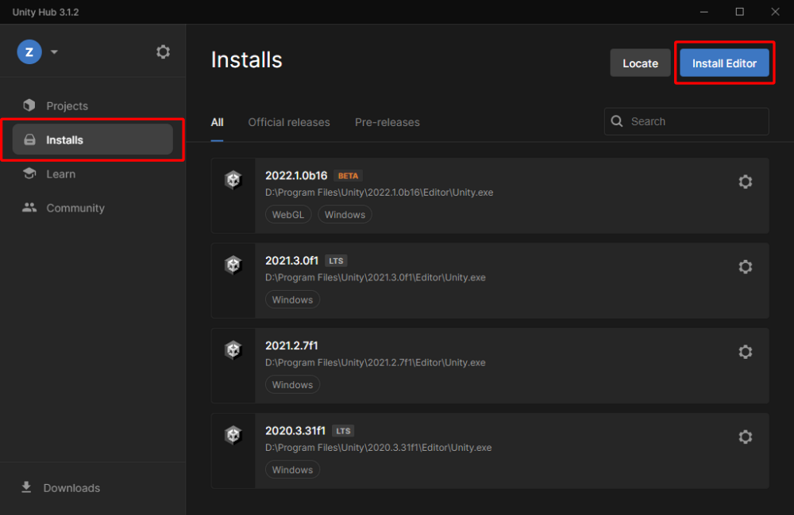
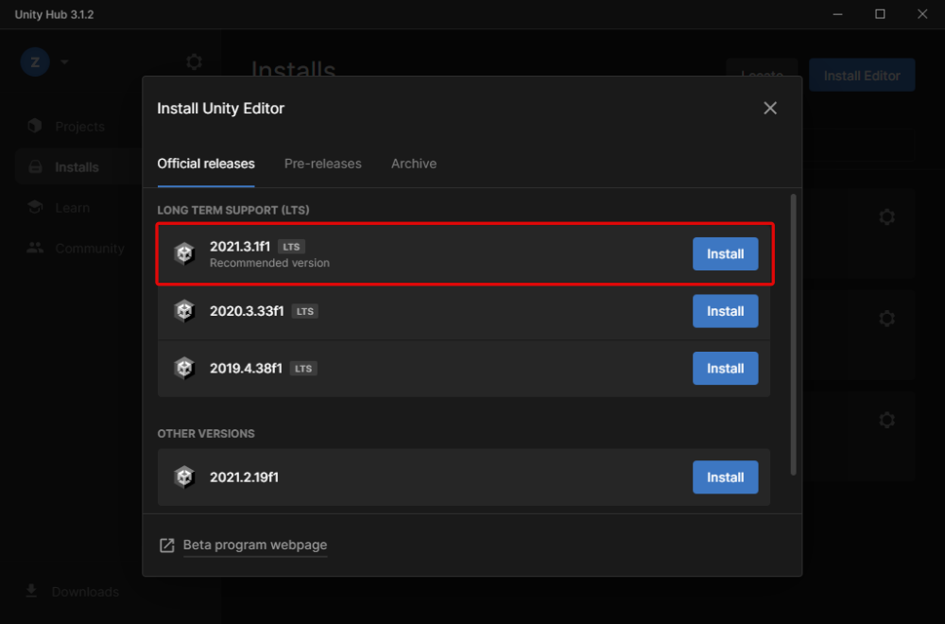

2. Registering a Unity Student Account
Unity offers students a free version of its software, Unity Student, through the GitHub Student Developer Pack. Here's how you can register:

2.1 Create a GitHub Account with Google
Visit https://github.com/join to create a GitHub account. Click on "Continue with Google" and use your Google account to sign up.

2.2 Apply for the GitHub Student Developer Pack
Go to the GitHub Student Developer Pack page at https://education.github.com/pack and click "Get your Pack". Follow the prompts to apply.

2.3 Verify Your Email
Check your email for a verification link from GitHub. Click on the link to verify your email address.

2.4 Wait for Approval
Once your application is submitted, it can take a few days to be approved. When you're approved, you'll get an email from GitHub.

2.5 Claim Your Unity Student Plan
After approval, visit Unity's educational product page at https://store.unity.com/academic/unity-student, click "Get started for free," and sign in with your new GitHub account. Follow the prompts to claim your Unity Student plan.

After the process, you should have both Unity and a Unity Student account registered and ready to use. Happy developing!

